Adriana Rodriguez

10/22/23

CSD 310 Module 1.2 Assignment

* Link to your GitHub repository

<https://github.com/nanirdz/csd-310.git>

* Screenshot of your GitHub repository

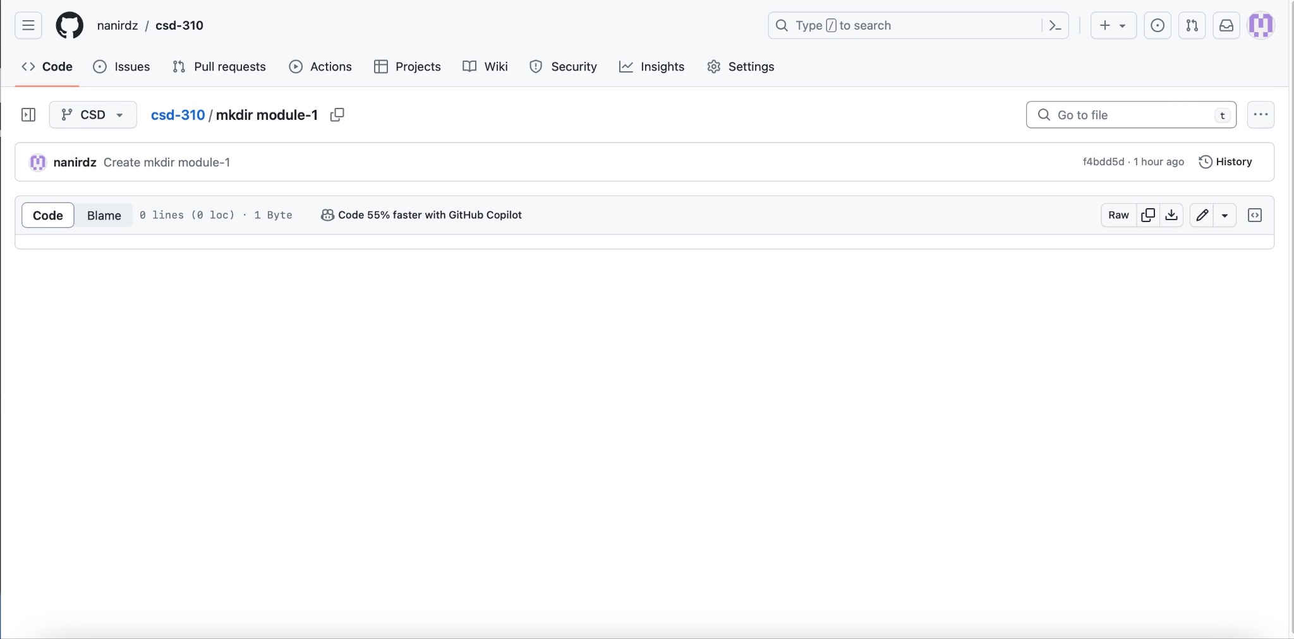

* Screenshot of your local directory (properly formatted)

